6 - Projection Pursuit Regression (an “old school” flexible model)

Projection pursuit does not get much attention these days as it has been replaced by neural networks which we will discuss in Chapter 7. Demonstrating the basics of projection pursuit regression however is a good precursor to the study of neural networks and other “similar” methods for regression problems.

Basic Form of the Projection Pursuit Regression Model

$$Y=f\left(X\right)=μ_{y}+\sum_{m=1}^{M_{o}}{β_{m}ϕ_{m}\left(a_{m}^{T}x\right)}+ϵ$$

where $\left\|a_{m}\right\|=1 i.e. \sqrt{a_{m1}^{2}+a_{m2}^{2}+…+a_{mp}^{2}}=1, μ_{y}=E\left(Y\right)$

and the $ϕ_{m}$ functions have been standardized, i.e.

$E\left(ϕ_{m}\left(a_{m}^{T}x\right)\right)=0 and Var\left(ϕ_{m}\left(a_{m}^{T}x\right)\right)=1, m=1,…, M_{o}$.

We then choose ${μ_{y},β}_{m}, ϕ_{m}, and a_{m}^{T}$ to minimize

$$\sum_{i=1}^{n}{{\left(y_{i}- μ_{y}-\sum_{m=1}^{M_{o}}{β_{m}ϕ_{m}\left(a_{m}^{T}x_{i}\right)}\right)}^{2}}$$

ACE models fit into this framework under the following restrictions:
$$θ\left(y\right)=y, { M}_{o}=p, β_{m}=1 for all m$$

$$a_{1}^{T}=\left(1,0,…, 0\right), a_{2}^{T}=\left(0,1,0,…,0\right), …,a_{p}^{T}=(0,0,…,0,1)$$

The estimated $ϕ_{m}\left(a_{m}^{T}x\right)=ϕ_{m}\left(x_{m}\right),$ the usual functions of the predictors found by ACE/AVAS.
and OLS multiple regression model with standardized predictors fits into this framework with the restrictions:

$$θ\left(y\right)=y, M_{o}=1 ϕ_{1}\left(t\right)=t\sqrt{β_{1}^{2}+β_{2}^{2}+…+β_{p}^{2} }$$
and $a_{1}^{T}=(β_{1},β_{2}, …,β_{p})/\sqrt{β_{1}^{2}+β_{2}^{2}+…+β_{p}^{2}}$

Key Property of Project Pursuit Models

Allows for the interaction between terms (i.e. products of terms)

Ex: Suppose $E\left(Y | X_{1},X_{2}\right)=X_{1}X_{2}$ then projection pursuit will find be handle this by

$$μ_{Y}=0, M_{o}=2, β_{1}=β_{2}=\frac{1}{4} , a_{1}^{T}=\left(1,1\right), a_{2}^{T}=\left(1,-1\right)$$

$$ϕ_{1}\left(t\right)=t^{2} and ϕ_{2}\left(t\right)=-t^{2}$$

Then we have,

$$ϕ_{1}\left(a_{1}^{T}x\right)={\left(x_{1}+x_{2}\right)}^{2}=x_{1}^{2}+2x_{1}x_{2}+x_{2}^{2}$$
$$ϕ_{2}\left(a_{2}^{T}x\right)=-{\left(x_{1}-x_{2}\right)}^{2}=-x_{1}^{2}+2x_{1}x_{2}-x_{2}^{2}$$

So that,

$$\sum_{m=1}^{2}{β_{m}ϕ_{m}\left(a_{m}^{T}x\right)=\frac{1}{4}\left(4x_{1}x_{2}\right)=x_{1}x_{2}}$$

Neither ACE/AVAS could model this type of behavior, and MARS would find interactions that are only products of checkmark functions.
Algorithm for Fitting a Projection Pursuit Regression

- Pick a starting trial direction $a_{1}$ and compute $z_{1i}=a_{1}^{T}x_{i}$. Then with $y_{i}^{1}=y_{i}-\overline{y}$ smooth a scatter plot of $(y_{i}^{1},a_{1}^{T}x_{i})$ to obtain ${\hat{ϕ}}_{1}={\hat{ϕ}}_{1,a_{1}}.$ Then $a_{1}$ is varied to minimize
$$\sum_{i=1}^{n}{{\left(y_{i}-{\hat{ϕ}}_{1,a_{1}}\left(z_{1i}\right)\right)}^{2}}$$
where for each new value for $a_{1}$ value a new ${\hat{ϕ}}_{1,a_{1}}$is obtained. The final results of both are then denoted ${\hat{a}}_{1}and {\hat{ϕ}}_{1}$ and then ${\hat{β}}_{1}$ is computed via OLS.

- The response is then updated to be $y_{i}^{(2)}=y_{i}- \overline{y}-{\hat{β}}_{1}{\hat{ϕ}}_{1}(z_{1i})$ and the term ${\hat{β}}_{2}{\hat{ϕ}}_{2}\left({\hat{a}}_{2}^{T}x_{i}\right)$ is found as in step 1.

- Repeat (2) until $M$ terms have been formed, giving final fittedvalues

$${\hat{y}}_{i}=\overline{y}+\sum_{m=1}^{M}{{\hat{β}}_{m}{\hat{ϕ}}_{m}\left({\hat{a}}_{m}^{T}x_{i}\right) i=1,…,n}$$

Example 1: The two variable interaction example in class is demonstrated below. The data is randomly generated so that the $Y=f\left(X_{1},X_{2}\right)+ϵ=X_{1}X_{2}+ϵ$
> set.seed(13)
> x1 <- runif(400,-1,1)
> x2 <- runif(400,-1,1)
> eps <- rnorm(400,0,.2)
> y <- x1*x2 + eps
> x <- cbind(x1,x2)
> plot(x1,y,main="Y vs. X1")
> plot(x2,y,main="Y vs. X2")
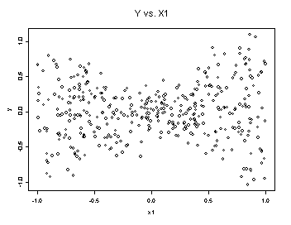
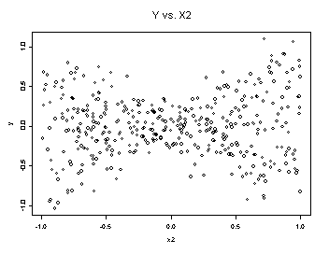
> pp <- ppr(x,y,nterms=2,max.term=3)
> PPplot(pp,bar=T)
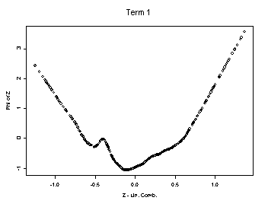
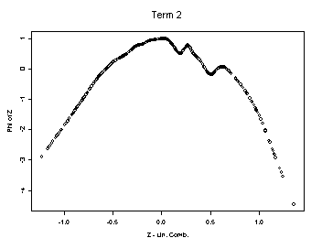
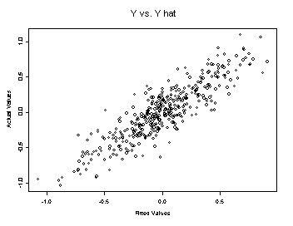
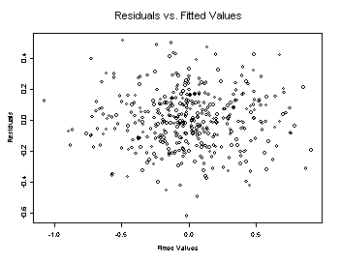
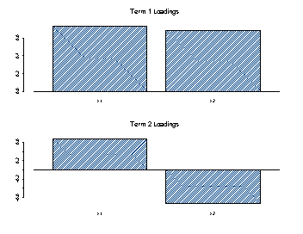
Here we see that projection pursuit correctly produces the theoretical results shown in class, namely $ϕ_{1}(x)=x^{2}$, $ϕ_{2}(x)=- x^{2}$, $a_{1}=(1 , 1)$ and $a_{2}=(1, -1)$.

Example 2: Florida Largemouth Bass Data
> attach(bass)
> names(bass)
> logalk <- log(Alkalinity)
> logchlor <- log(Chlorophyll)
> logca <- log(Calcium)
> x <- cbind(logalk,logchlor,logca,pH)
> y <- Mercury.3yr^.3333

Initially we run projection pursuit with 1 term up to a suitable maximum number of terms. We can then examine a plot of the R-square or % of variation unexplained vs. the number of terms in the regression to get an idea of what number we should use in “final” projection pursuit model.
> bass.pp <- ppr(x,y,nterms=1,max.term=8)
> PPplot(bass.pp,full=F) # full = F means don’t plot terms etc. just show the plot of
% of unexplained variation vs. # of terms in model.

The plot is shown below.
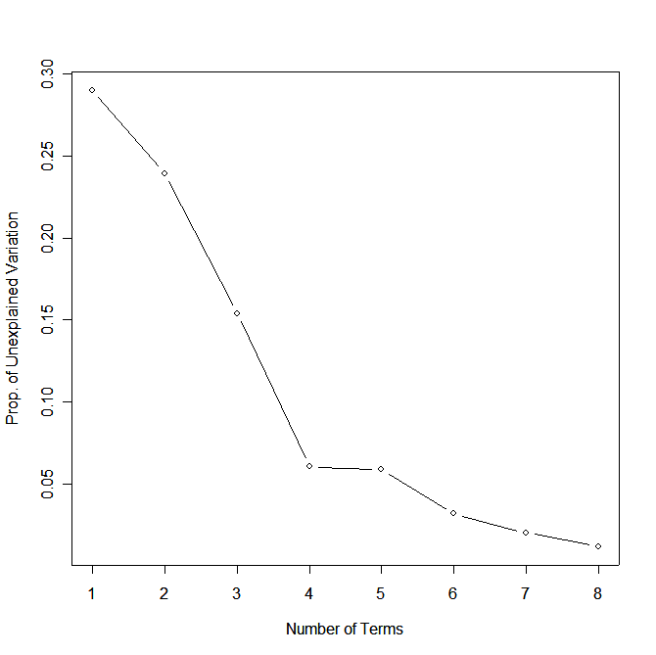
It appears that 4 terms would be good candidate for a “final” model. Therefore we rerun the regression with nterms=4.

> bass.pp2 <- ppr(x,y,nterms=4,max.term=8)
for j = 1,2,3,4
> PPplot(bass.pp2,bar=T)

To visualize the linear combination terms that are formed we can look at barplots of the variable loadings (bar = T).

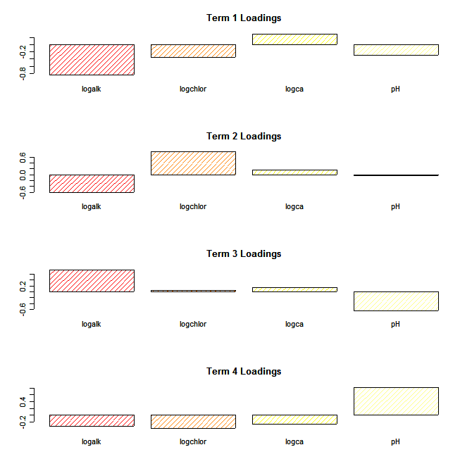
These don’t aid in interpretation of the results much, but they do give some idea of what variables are most important. For example, log(Alkalinity) is prominently loaded in the first three terms.

6.2 - Fine Tuning the Projection Pursuit Regression Fit

Fine tuning the projection pursuit model involves choosing how many terms to create, which is denoted by M in the fitted model formulation shown below, and choosing how smooth or wiggly the nonparametric estimates of $\hat{ϕ_{m}}(a_{m}^{T}x)$ are.

$${\hat{y}}_{i}=\overline{y}+\sum_{m=1}^{M}{{\hat{β}}_{m}{\hat{ϕ}}_{m}\left({\hat{a}}_{m}^{T}x_{i}\right) i=1,…,n}$$
Most of the fine tuning has to do with the smoothers that are used to estimate $\hat{ϕ_{m}}\left(a_{m}^{T}x\right), m=1,…,M.$ This involves choosing the method used to do the actual smoothing, and controlling how wiggly the smooth from the chosen method can be.

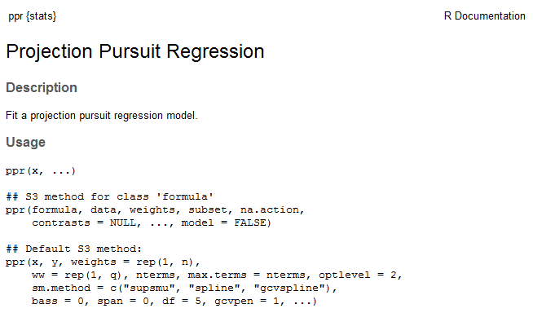

sm.method: the method used for smoothing the ridge functions. The default is to use Friedman's super smoother 'supsmu'. The alternatives are to use the smoothing spline code underlying smooth.spline, either with a specified equivalent degrees of freedom or effective number of parameters for each of the ridge functions, or to allow the smoothness to be chosen by GCV.

bass: super smoother bass tone control used with automatic span selection (see 'supsmu'); the range of values is 0 to 10, with larger values resulting in increased smoothing.

span: super smoother span control (see 'supsmu'). The default, '0', results in automatic
span selection by local cross-validation. 'span' can also take a value in '(0, 1]'.

df: if sm.method is spline specifies the smoothness of each ridge or linear
combination term via the requested equivalent degrees of freedom.

Aside: In recall for OLS regression fitted values are obtained via the Hat matrix. For the model,
$$Y=f\left(X\right)= β_{o}+β_{1}U_{1}+…+β_{k-1}U_{k-1}$$

parameter estimates and fitted values are given by
$$Y=U\hat{β}=U{\left(U^{T}U\right)}^{-1}U^{T}Y=HY$$The degrees of freedom used by the model is k which is equal to the trace of Hat matrix, $tr\left(H\right)=k$. Smoothers can be expressed in a similar fashion where the fitted values from
the smooth are found by taking specific linear combination of the Y’s where the
linear combinations come from the ${X_{j}^{'}s or U}_{j}’s$ and the “amount” of smoothing that occurs which controlled by some parameter we will generically denote as,
i.e. $Y=S_{λ}Y$. The trace of the smoother matrix $S_{λ}$ is the “effective or equivalent number of parameters (df or enp) used by the smooth”, i.e. $tr\left(S_{λ}\right)=df or enp.$

gcvpen: if 'sm.method' is '"gcvspline"' this is the penalty () used in the GCV selection for each degree of freedom used.

FINE TUNING THE PPR Model:
> attach(bass)
> names(bass)
[1] "ID" "Alkalinity" "pH" "Calcium" "Chlorophyll"
[6] "Avg.Mercury" "No.samples" "minimum" "maximum" "Mercury.3yr"
[11] "age.data"
> xs <- scale(cbind(logalk,logchlor,logca,pH))
> y <- Mercury.3yr^.333
> bass.pp <- ppr(xs,y,nterms=1,max.terms=10)
> PPplot(bass.pp,full=F)
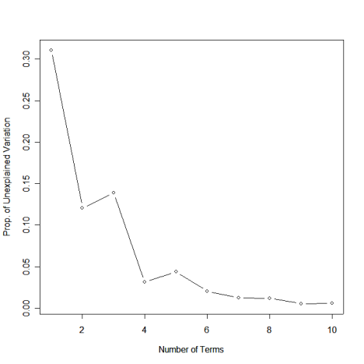
> bass.pp <- ppr(xs,y,nterms=4,max.terms=4)
> PPplot(bass.pp,bar=T)
The smooths certainly look noisy and thus we almost surely overfitting our data. This will lead to model with poor predictive abilities. We can try using different smoothers or increasing the degree of smoothing done super smoother, which is the default smoother.

ADJUSTING THE BASS
> bass.pp2 <- ppr(xs,y,nterms=4,max.terms=4,bass=5) # try 7 and 10 also
> PPplot(bass.pp2,bar=T)

bass = 5 bass = 7 bass = 10

ADJUSTING THE SPAN (the fraction of data in the smoother window)
> bass.pp2 <- ppr(xs,y,nterms=4,max.terms=4,span=.25)
> PPplot(bass.pp2,bar=T)
span = .25 span = .50 span = .75

USING GCVSPLINE vs. SUPER SMOOTHER
> bass.pp2 <-ppr(xs,y,nterms=4,max.terms=4,sm.method="gcvspline",gcvpen=3)
> PPplot(bass.pp2,bar=T)
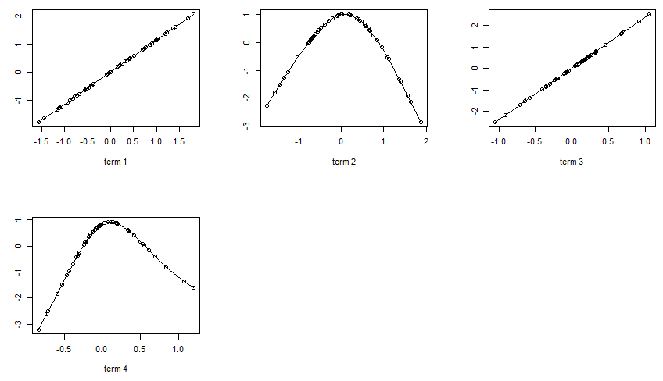
Increasing this along with the number terms provides increased flexibility at the possible risk of overfitting.
gcvpen = 3 gcvpen = 4 gcvpen = 5

USING SPLINE vs. SUPERSMOOTHER (not recommended)
> bass.pp3 <- ppr(xs,y,nterms=2,max.terms=10,sm.method=”spline”,df=2)
> PPplot(bass.pp3,full=F)
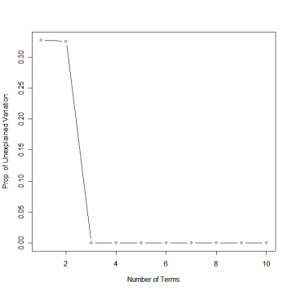
Note: This does not mean perfect fit. The algorithm does allow fitting additional terms with this few of degrees of freedom for the smoother used to estimate the $ϕ_{m}'s$.

Example 3: Predicting the Age of Abalone

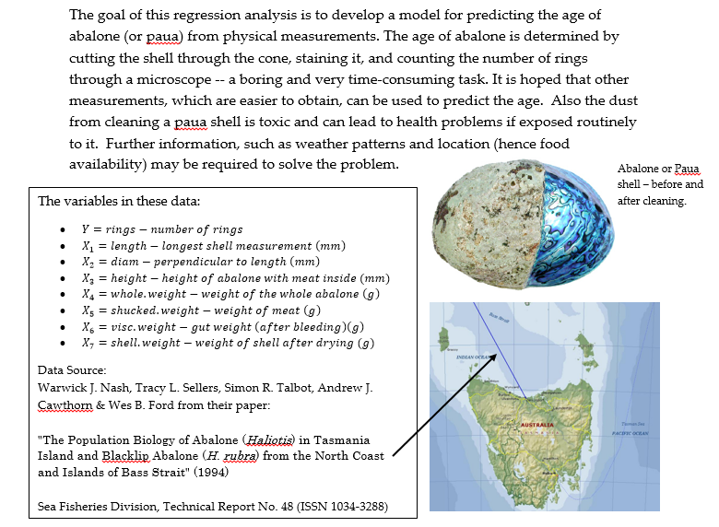
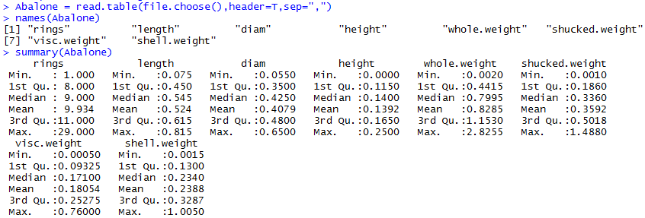

Notice that height has a minimum value of zero. While normally we may not worry about this, if we plan to employ transformation methods such the Box-Cox procedure the zeroes in height pose a problem. The caret package has a function called preProcess which is a very general tool for performing various pre-processing tasks on a set of numeric variables. These pre-processing tasks include the Box-Cox transformation for transforming numeric variables to approximate normality, scaling/standardization (i.e. converting numeric variables to z-scores), and performing dimension reduction techniques such as principal component analysis (PCA). We will be discussing PCA later in the course. For these data we will demonstrate the use of the Box-Cox transformation.

Below is a scatterplot matrix of these data in the original scale.
> pairs.plus(Abalone)
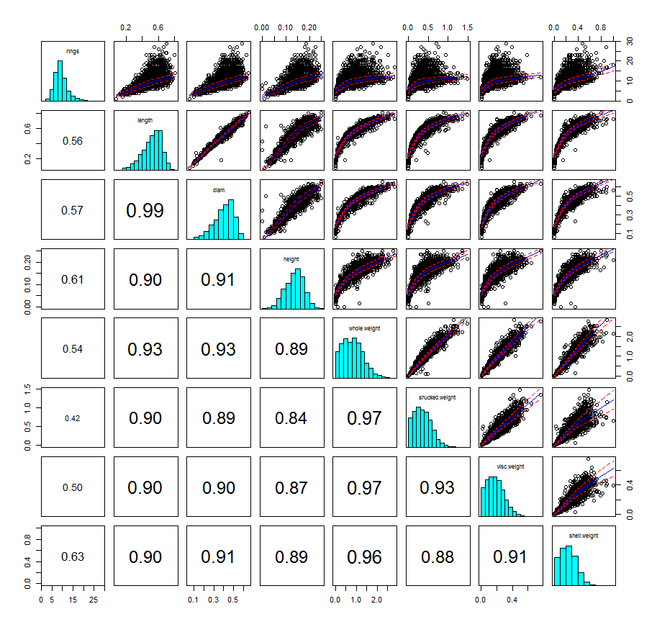

In order to use the Box-Cox procedure for these data we need to add a constant height of to deal with the fact that it contain zeroes.
> Abalone$height = Abalone$height+.001
> Abalone.PP = preProcess(Abalone,method="BoxCox")
> Abalone.PP$bc
$rings
Box-Cox Transformation

4175 data points used to estimate Lambda

Input data summary:
Min. 1st Qu. Median Mean 3rd Qu. Max.
1.000 8.000 9.000 9.934 11.000 29.000

Largest/Smallest: 29
Sample Skewness: 1.11

Estimated Lambda: 0.2

$length
Box-Cox Transformation

4175 data points used to estimate Lambda

Input data summary:
Min. 1st Qu. Median Mean 3rd Qu. Max.
0.075 0.450 0.545 0.524 0.615 0.815

Largest/Smallest: 10.9
Sample Skewness: -0.64

Estimated Lambda: 1.9

$diam
Box-Cox Transformation

4175 data points used to estimate Lambda

Input data summary:
Min. 1st Qu. Median Mean 3rd Qu. Max.
0.0550 0.3500 0.4250 0.4079 0.4800 0.6500

Largest/Smallest: 11.8
Sample Skewness: -0.609

Estimated Lambda: 1.8

$height
Box-Cox Transformation

4175 data points used to estimate Lambda

Input data summary:
Min. 1st Qu. Median Mean 3rd Qu. Max.
0.0010 0.1160 0.1410 0.1402 0.1660 0.2510

Largest/Smallest: 251
Sample Skewness: -0.264

Estimated Lambda: 1.2

$whole.weight
Box-Cox Transformation

4175 data points used to estimate Lambda

Input data summary:
Min. 1st Qu. Median Mean 3rd Qu. Max.
0.0020 0.4415 0.7995 0.8285 1.1530 2.8260

Largest/Smallest: 1410
Sample Skewness: 0.528

Estimated Lambda: 0.6

$shucked.weight
Box-Cox Transformation

4175 data points used to estimate Lambda

Input data summary:
Min. 1st Qu. Median Mean 3rd Qu. Max.
0.0010 0.1860 0.3360 0.3592 0.5017 1.4880

Largest/Smallest: 1490
Sample Skewness: 0.714

Estimated Lambda: 0.5

$visc.weight
Box-Cox Transformation

4175 data points used to estimate Lambda

Input data summary:
Min. 1st Qu. Median Mean 3rd Qu. Max.
0.00050 0.09325 0.17100 0.18050 0.25280 0.76000

Largest/Smallest: 1520
Sample Skewness: 0.589

Estimated Lambda: 0.5

$shell.weight
Box-Cox Transformation

4175 data points used to estimate Lambda

Input data summary:
Min. 1st Qu. Median Mean 3rd Qu. Max.
0.0015 0.1300 0.2340 0.2388 0.3288 1.0050

Largest/Smallest: 670
Sample Skewness: 0.62

Estimated Lambda: 0.6
While I would not advocate blindly applying these transformations in this case as the number of predictors is not that large, we will apply them and proceed with developing a PPR model for the transformed response (Note: $λ=0.20 or\frac{1}{5} for Y)$.

> Abalone.PP = predict(Abalone.PP,Abalone) as no log ($λ=0)$ or negative
powers ($λ<0)$ were used we
apply the transformations to
directly to original variables.

We can now inspect the relationships amongst these variables in the transformed scale and their univariate distributions.
> pairs.plus(Abalone.PP)
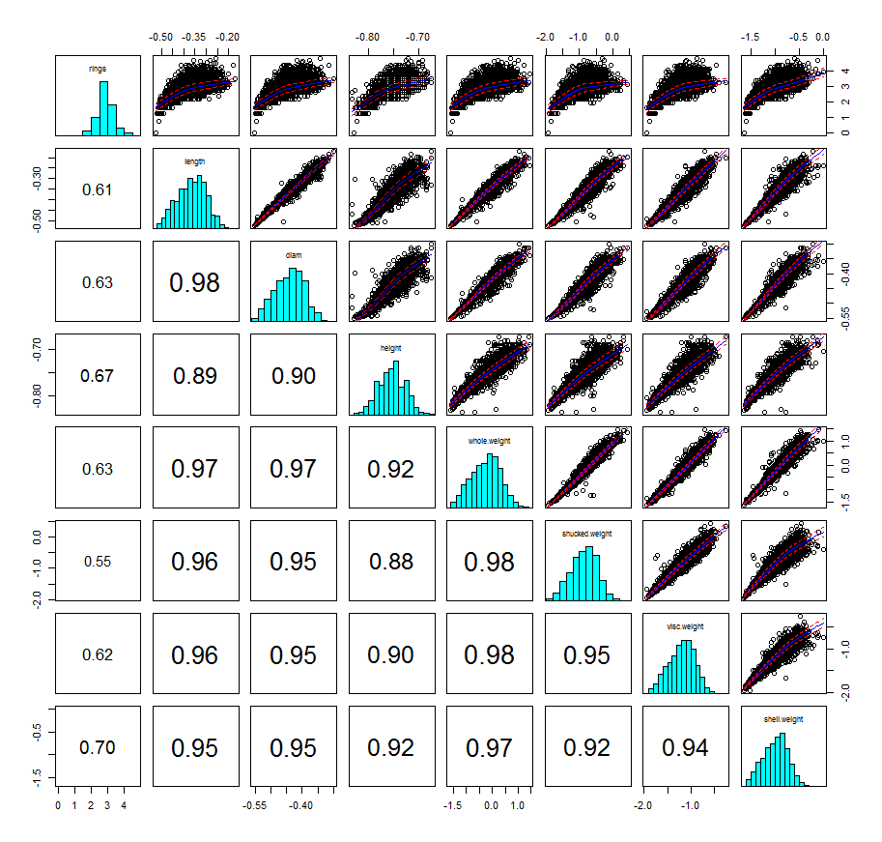
We will now fit a preliminary PPR model with up to 10 terms.
> Abalone.ppr1 = ppr(rings~.,data=Abalone.PP,nterms=1,max.terms=10,span=0.05)
> PPplot(Abalone.ppr1)
Notice here I am using the wild card model formula y ~ . which the most recent version of ppr supports.
Hit <Return> to see next plot:
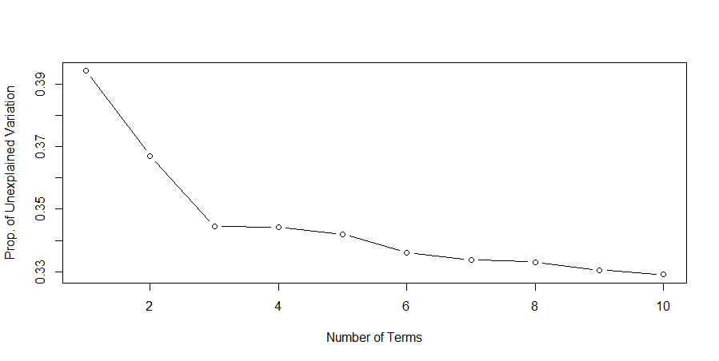
We might choose $M = 6-8$ terms on the basis of this plot.

> Abalone.ppr2 = ppr(Rings~.,data=Abalone.PP,nterms=7,span=0.05)
> PPplot(Abalone.ppr2)
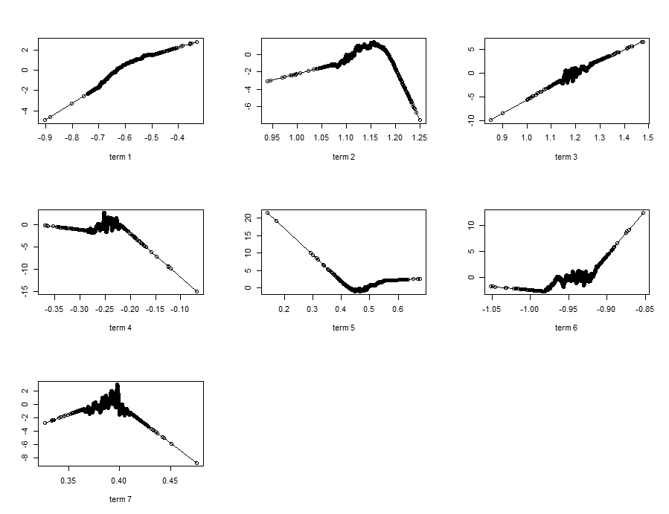
These smooths have some cusps and are very wiggly which we can eliminate by fine tuning the smoothers a bit by increasing the span or the bass for example.
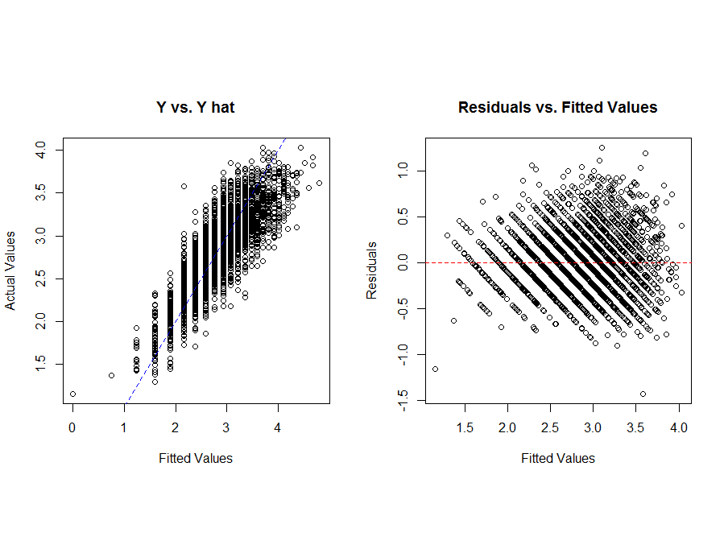

> Abalone.ppr2 = ppr(Rings~.,data=Abalone.PP,nterms=7,bass=1)
> PPplot(Abalone.ppr2,bar=T)
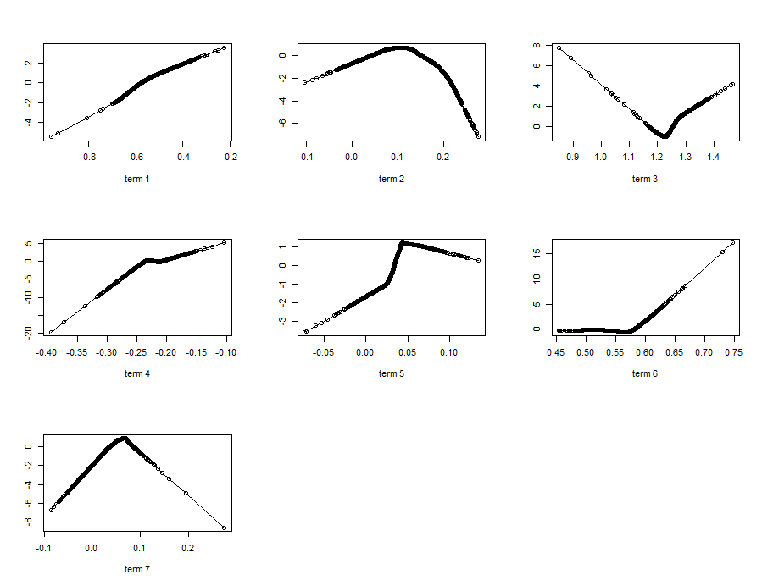
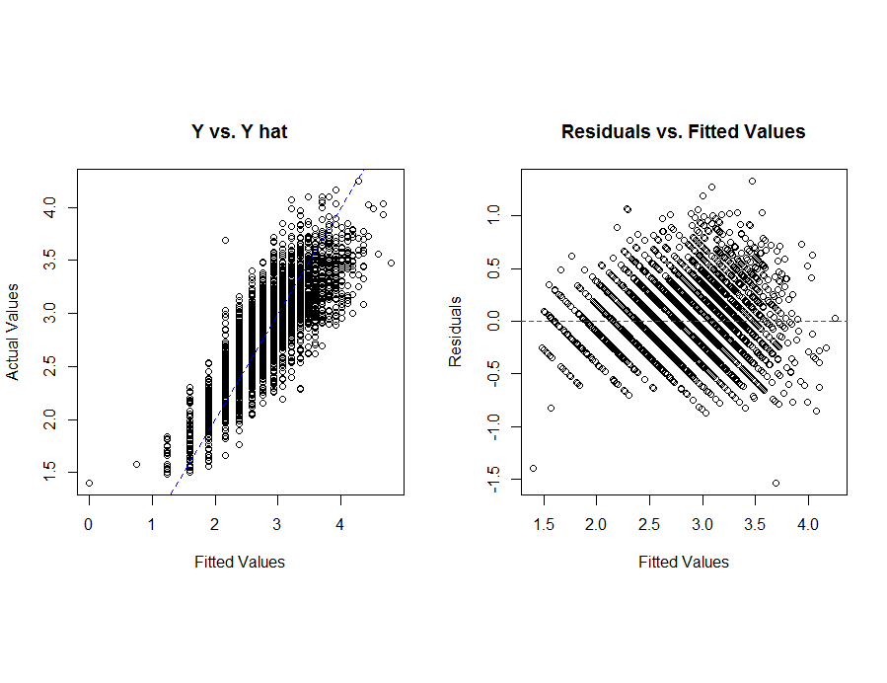

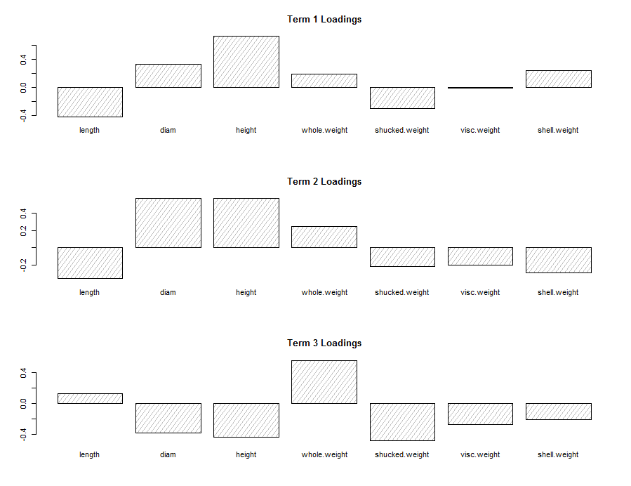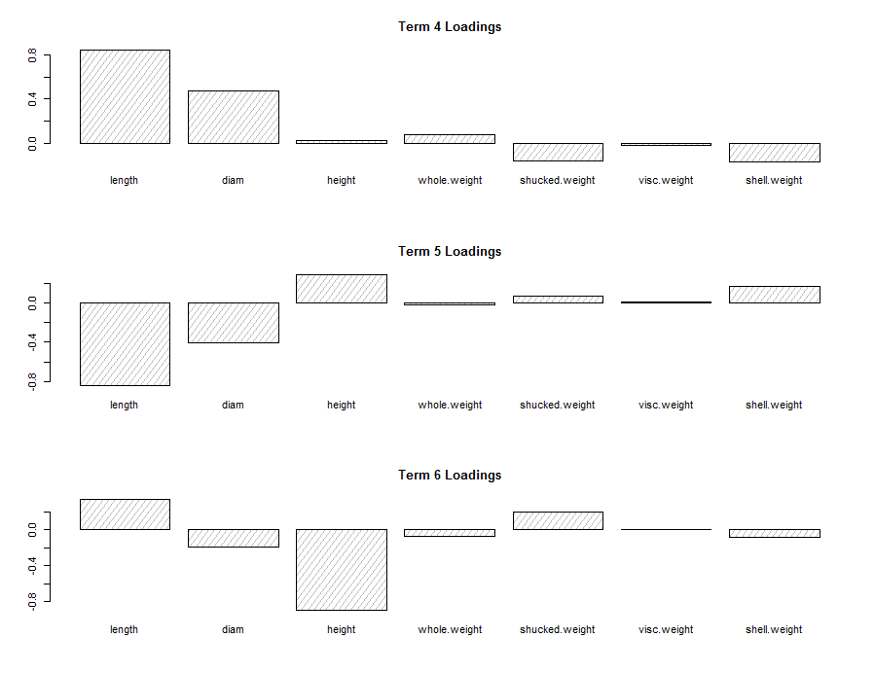
Visualization of the coefficients for the linear combinations, $a_{m}^{T}x$.
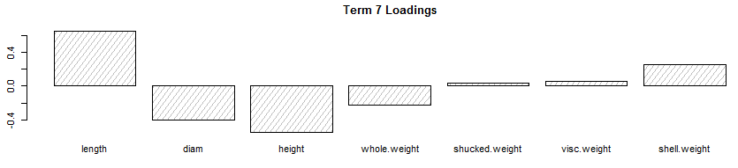
The fit looks good for the most part, but we should perform cross-validation to further fine tune this model for prediction purposes and to compare it to other models we have considered MLR (possibly CERES, ACE/AVAS assisted) and MARS.
Rather than code a k-fold cross-validation, split-sample, or Monte Carlo version of either function for cross-validating a PPR model we can use functions in the library bootstrap to do some of the heavy lifting for us. The function crossval in this library performs k-fold cross-validation for any modeling method where fitting and obtaining predicted values for future cases can be done easily, which is the case for most methods. The crossval has the following form from it’s R help file:
crossval {bootstrap} | R Documentation

K-fold Cross-Validation

Description
See Efron and Tibshirani (1993) for details on this function.

Usage
crossval(x, y, theta.fit, theta.predict, ..., ngroup=n)

Arguments
x | a matrix containing the predictor (regressor) values. Each row corresponds to an observation.
y | a vector containing the response values
theta.fit | function to be cross-validated. Takes x and y as an argument. See example below.
theta.predict | function producing predicted values for theta.fit. Arguments are a matrix x of predictors and fit object produced by theta.fit. See example below.
... | any additional arguments to be passed to theta.fit
ngroup | optional argument specifying the number of groups formed . Default is ngroup=sample size, corresponding to leave-one out cross-validation.

The required arguments are matrix of predictors/terms to use (x), a response vector (y), a function we have to write called theta.fit which specifies how to fit the model to be cross-validated, a function theta.predict we again have to write that specifies how to obtain predictions for observations not used to fit the model, and the number of folds to use in the k-fold cross-validation (ngroups).
As a single call to this function will only perform one replication of a k-fold cross-validation we will first write a function to perform Monte Carlo k-fold cross-validation a specified number of times, saving the results from each.
Generic Function to Perform Monte-Carlo k-fold Cross-Validation (uses crossval)
CVK = function(x,y,theta.fit,theta.predict,ngroup=10,reps=100) {
require(bootstrap)
cv = rep(0,reps)
for (i in 1:reps) {
results = crossval(x,y,theta.fit,theta.predict,ngroup=ngroup)
cv[i] = sum((y - results$cv.fit)^2)/length(y)
}
cv
}

We can now use this function to perform cross-validation of our $M = 7$ and
span = 0.333 PPR model above.

> Ab.X = Abalone.PP[,-1] form predictor matrix(x)
> Ab.y = Abalone.PP[,1] form response vector y

Create the function that will fit our PPR model with desired specifications
> theta.fitppr = function(x,y){ppr(x,y,nterms=7,bass=1)}

Create function that will predict the response value given a set of predictor values.
> theta.predictppr = function(fit,x){predict(fit,x)}

We can now run the CVK function above for our chosen PPR model.
> results = CVK(Ab.X,Ab.y,theta.fitppr,theta.predictppr,ngroup=10,reps=25)
> results
> MSEP.ppr = mean(results)
> RMSEP.ppr = sqrt(MSEP.ppr)
> MSEP.ppr
[1] 0.08869406
> RMSEP.ppr
[1] 0.2978155

These prediction quality measurements are for the response is the transformed scale using the Box-Cox family which is $T\left(Y\right)=(\sqrt[5]{rings}-1)/.20$. To measure performance in the original scale we need to modify the CVK function to convert the predictions and actual response values to the originals scale within the function.

> CVK.ab = edit(CVK)
> CVK.ab = function(x,y,theta.fit,theta.predict,ngroup=10,reps=100) {
require(bootstrap)
cv = rep(0,reps)
for (i in 1:reps) {
results = crossval(x,y,theta.fit,theta.predict,ngroup=ngroup)
ystar = (0.2*y + 1)^5
ypred = (0.2*results$cv.fit+1)^5
cv[i] = sum((ystar-ypred)^2)/length(ystar)
}
cv
}
> results = CVK.ab(Ab.X,Ab.y,theta.fitppr,theta.predictppr,ngroup=10,reps=25)
> results
> MSEP.ppr = mean(results)
[1] 4.38799
> RMSEP.ppr = sqrt(mean(results))
[1] 2.094753

We can easily extend CVK functions above to compute MAEP and MAPEP as well.
CVK2 = function(x,y,theta.fit,theta.predict,ngroup=10,reps=100) {
require(bootstrap)
MSEP = rep(0,reps)
MAEP = rep(0,reps)
MAPEP = rep(0,reps)
n = length(y)
for (i in 1:reps) {
results = crossval(x,y,theta.fit,theta.predict,ngroup=ngroup)
MSEP[i] = sum((y - results$cv.fit)^2)/n
MAEP[i] = sum(abs(y-results$cv.fit))/n
MAPEP[i] = sum(abs(y[y!=0]-results$cv.fit[y!=0])/y[y!=0])/length(y[y!=0])
}
RMSEP = sqrt(mean(MSEP))
MAE = mean(MAEP)
MAPE = mean(MAPEP)
cat("RMSEP\n")
cat("===============\n")
cat(RMSEP,"\n\n")
cat("MAE\n")
cat("===============\n")
cat(MAE,"\n\n")
cat("MAPE\n")
cat("===============\n")
cat(MAPE,"\n\n")
temp = data.frame(MSEP=MSEP,MAEP=MAEP,MAPEP=MAPEP)
return(temp)
}

For the Abalone data with the Box-Cox ($λ=0.2)$ transformation we would need to alter the code to undo the transformation for the actual response values and those returned from the crossval function.
CVK2.ab = function(x,y,theta.fit,theta.predict,ngroup=10,reps=100) {
require(bootstrap)
MSEP = rep(0,reps)
MAEP = rep(0,reps)
MAPEP = rep(0,reps)
n = length(y)
for (i in 1:reps) {
results = crossval(x,y,theta.fit,theta.predict,ngroup=ngroup)
ystar = (0.2*y+1)^5
ypred = (0.2*results$cv.fit+1)^5
MSEP[i] = sum((ystar - ypred)^2)/n
MAEP[i] = sum(abs(ystar-ypred))/n
MAPEP[i] = sum(abs(ystar[ystar!=0]-ypred[ystar!=0])/ystar[ystar!=0])/length(ystar[ystar!=0])
}
RMSEP = sqrt(mean(MSEP))
MAE = mean(MAEP)
MAPE = mean(MAPEP)
cat("RMSEP\n")
cat("===============\n")
cat(RMSEP,"\n\n")
cat("MAE\n")
cat("===============\n")
cat(MAE,"\n\n")
cat("MAPE\n")
cat("===============\n")
cat(MAPE,"\n\n")
temp = data.frame(MSEP=MSEP,MAEP=MAEP,MAPEP=MAPEP)
return(temp)
}

> results.ppr = CVK2.ab(Ab.X,Ab.y,theta.fitppr,theta.predictppr,ngroup=5,reps=25)
RMSEP
===============
2.098229

MAE
===============
1.47536

MAPE
===============
0.1449155

We will now compare the PPR model to the “best” (actually reasonable) model using MARS.

> ab.mars = earth(rings~.,data=Abalone.PP,nk=20,ncross=20,nfold=5,keepxy=T)
> plot(ab.mars)
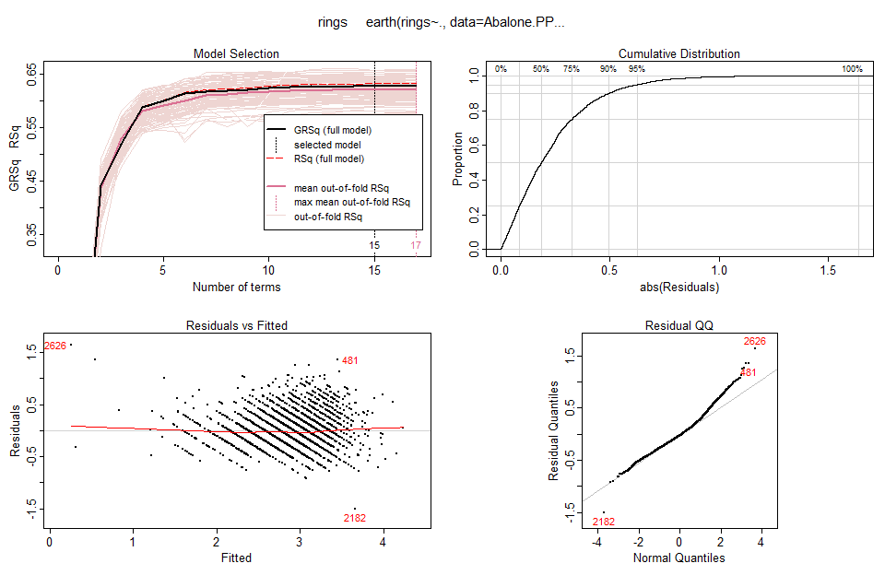
> theta.fitmars = function(x,y) {earth(x,y,degree=2,nfold=5,nk=20)}
> theta.predmars = function(fit,x) {predict(fit,x)}

> results = CVK2.ab(Ab.X,Ab.y,theta.fitmars,theta.predictmars,ngroup=5,reps=25)
RMSEP
===============
2.138605

MAE
===============
1.509889

MAPE
===============
0.1486187

Notice that in the theta.fitmars function we have specified that when developing a model to $(k-1)$ folds used in obtaining the fit we are performing an internal 5-fold cross-validation to select the model. Thus the MARS model chosen for each fit utilizes the same criteria (5-fold CV in this case) that the CVK2.ab function does.

The PPR model slightly outperforms the MARS model given these data in the transformed scales chosen. However, the MARS model is much more interpretable the PPR model in general.

